**Proposal:**

**Spill Control and Countermeasure Plan (SPCC Plan) Site Evaluation & SPCC Drafting**

*Submitted To*

**Ed Staub & Sons Petroleum, Inc.**

**Test Address line 1**

**Klamath Falls, OR 97601**

**24 11 2020**

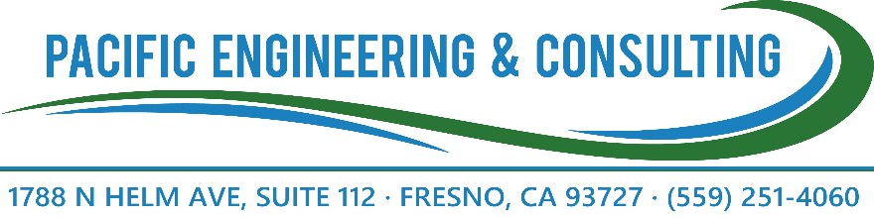

Pacific Engineering & Consulting

Company Credentials and Certifications

|  |  |
| --- | --- |
| **Name of Organization:** | Pacific Engineering & Consulting |
| **Office Address:** | 1788 N Helm Ave Suite 112 Fresno CA, 93727 |
| **Web Address:** | www.pacificmgt.com |
| **Telephone Number:** | (559) 251-4060 |
| **Fax:** | (559) 251-4060 |
| **DUNS Number:** | 196553770 |
| **Size of Company:** | Small under NAICS  541330 - Engineering Services  541620 - Environmental Consulting Service  541690 - Other Scientific and Technical Consulting Services |
| **Point of Contact:** | Daniel Elliott  Project Manager  (559) 251-4060 ext. 105  daniel@pacificmgt.com |

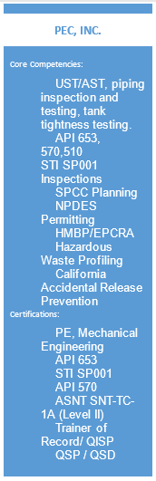

1. **Introduction:**

Pacific Engineering & Consulting was founded in 1982 and is headquartered in Fresno, CA. We currently specialize in engineering and environmental services, specifically in performing certified inspection(s) and SPCC Plans. Pacific Engineering & Consulting has conducted Aboveground and Underground Storage Tank (AST/UST) inspections and testing for a variety of US Government agencies and Private Industry customers. We have also done pressure testing, pressure vessel inspection, Spill Prevention Control and Countermeasure (SPCC) plans, Facility Response Plans (FRP). For government and commercial customers throughout the continental US. Pacific Engineering & Consulting is certified to conduct a variety of inspections including: storage tanks, piping, pressure vessels, OSHA’s Process Safety Management integrity inspections, Non-Destructive Examination, National Association of Corrosion Engineer’s coatings, and cathodic protection systems.

1. **Project Approach:**

We propose the following scope of services to maintain compliance with the SPCC Rules and Regulations:

* 1. Conduct a site compliance evaluation and walk-down each oil storage container/tank.
  2. Determine the type and construction standard of every oil storage container/tank.
  3. Evaluate secondary containment, inspecting the imperviousness and ability to hold the largest container’s contents plus the rainwater from a 25-year 24-hour storm.
  4. Evaluate the facility’s risk to navigable waters of the United States.
  5. Establish tank integrity test intervals in accordance with applicable industry standards (STI-SP001 or API653.)
  6. Evaluate current spill kits and determine if they are adequate to contain the most likely spill outside containment.
  7. Ensure overfill prevention measures are adequate and/or recommend tank upgrades.
  8. Draft a site map showing facility layout, spill control structures, and drainage patterns.
  9. We will write the SPCC Plan in accordance with most current state and federal oil pollution prevention regulations.
  10. The fieldwork will be supervised by Daniel Elliott and Pacific Engineering & Consulting personnel.

1. **Contractor Qualification**

Jared Shuman – Pacific Engineering & Consulting

**Education:**

MBA, California State University - Fresno - 2012

BS Mechanical Engineering, UCLA - 2008

**Expertise:**

Certified Professional Engineer (PE) in the state of California – Certification #M36728

Tank Inspector with certifications that include:

API-653 Aboveground Storage Tank Inspector – Certification #56100

STI-001 Aboveground Storage Tank Inspector – Certification # 121286

Mr. Shuman is a mechanical engineer experienced in storage tank structural analysis and in various hazardous material management and spill prevention planning and review processes.

**Experience:**

Consulting Engineer – 2010 to present: Lead engineer for Pacific Management Services / Pacific Engineering & Consulting specializing in environmental compliance inspections and planning. Has provided recommended updates to a range of environmental protection plans including Hazardous Materials Business Plans (HMBP), Storm Water Pollution Prevention Plans (SWPPP) and Spill Prevention Control and Countermeasure (SPCC) Plans. Evaluated petrochemical storage tanks in accordance with following applicable codes and standards:

CAL EPA (CUPA, SWRCB, ARB, CalOSHA),

American Petroleum Institute (API),

Steel Tank Institute (STI),

American Society for Mechanical Engineers (ASME),

Underwriters Laboratory UL-142

National Fire Prevention Association (NFPA) 30,

40 Code of Federal Regulation (CFR), and

State and Federal regulation.

**Specific Related Projects:**

* 1. Inspector and Lead Engineer for Cleaning and Inspection of six ASTs at Air Force Plant 42. Conducted STI-SP001 inspections and certified calibration charts for all six tanks
  2. Lead inspector for STI-SP001 inspection digester tank for Las Gallinas Valley Sanitary District, which included an ultrasonic thickness test and engineering evaluation
  3. Inspector: Conducted Hazardous Waste Assessments of two used oil tanks for Cornerstone including ultrasonic thickness testing, pressure-decay test, seismic evaluation and a visual inspection of the tank appurtenances.
  4. Inspected and evaluation of the Fresno Veterans Administration Hospital's petroleum storage tanks and developed procedures for spill response and emergency notification.

1. **Project Cost/Limitations**

The estimated cost to provide the above-mentioned engineering services is $59.00.

A breakdown of the estimated fees is provided below:

|  |  |  |  |
| --- | --- | --- | --- |
| **Task** | **Quantity** | **Rate** | **Total** |
| SPCC Plan | 1 | $3,495.00 | $0.00 |
| Lodging | 0 | $150.00 | $0.00 |
| Travel | 0 hours | $40.00 | $0.00 |
| Per Diem | 1 day | $55.00 | $55.00 |
| Mileage | 0 miles | $0.55 | $0.00 |
| Total Estimated Cost | | | $59.00 |

If there are any questions or concerns regarding the proposed services and associated fees, please do not hesitate to contact Pacific Engineering & Consulting at your earliest convenience. Pacific Engineering & Consulting strives to satisfy our client’s needs and meet their expectations. We will make every effort to accommodate requested changes in our understanding of the project, assumptions, scope, or services, as appropriate.

Proposed costs are good for 60 days from the date of issue noted above.

Extra work, if required, will be completed on a separately negotiated lump sum basis or on a "time and materials" basis according to Pacific Engineering & Consulting’s fee schedule. No extra work will be performed without written authorization from the client.

1. **Conclusion**

Pacific Engineering & Consulting will administer this project in accordance with all applicable Ed Staub & Sons Petroleum, Inc. requirements, industry standards, and engineering best practices. Our staff of Professional Engineers and certified personnel are excited at the opportunity to assist Ed Staub & Sons Petroleum, Inc. environmental compliance needs.

Best Regards

Daniel Elliott

STI Inspector, #AC44220

API 653 Inspector, #70788

API 570 Inspector, #82919

QISP #00969

NDT Level II

Please Sign and Return to Pacific Engineering & Consulting.

Accepted by:

Ed Staub & Sons Petroleum, Inc. / Authorized Representative

____________________________________

Signature

____________________________________

Title Date